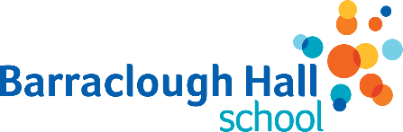
Barraclough Hall School Uniform Order Form
Polo Shirt-White  £9.90 | Sweatshirt- Royal  £12.30 | Sweatshirt Cardigan- Royal  £13.50 | PE T-shirt- Royal  £6.60 | Fleece (Optional)  £23.34  Hoodie (Optional)  £18.00

These items are available in the following sizes:
7-8 years 9-10 years 11-12 years
13 years (PE T-shirts are 11-13) Small (chest size 36”) Medium (chest size 38-40”)
--------------------------------------------------------------------------------------------------------------------------
Please complete the form below:
Your name:
Your child’s name:
Your child’s class:
Item | Size  required | Quantity | Price  (each) | Total
TOTAL FOR THIS ORDER:

Signature:
Date:
Please return this form to the School Office. Payment method to be confirmed.

