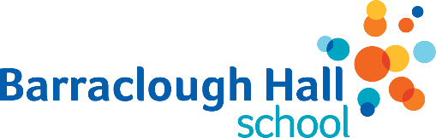
PARENTAL DIRECT MARKETING CONSENT
Please complete all shaded boxes on these forms

The school may wish to share with you details of events/activities from carefully selected providers, including our parents’ group. We need your consent below to allow us to send this information by email / messaging / leaflet
Name of School | Barraclough Hall School
Name of Child |  | Year Group
Name of Parent(s)/Carer(s)
Please indicate Y or N to the following boxes:
I give consent to receive information from non-profit organisations connected to the school
I give consent to receive information from carefully selected providers that promote activities for children (e.g. library services, holiday clubs)

Signature of Parents/Carers with Legal Responsibility for the Child  (please use an electronic signature where possible – we will send this back to you for signing if not) | Date

You may withdraw your consent at any time.
Please notify the office of any changes to these arrangements.

