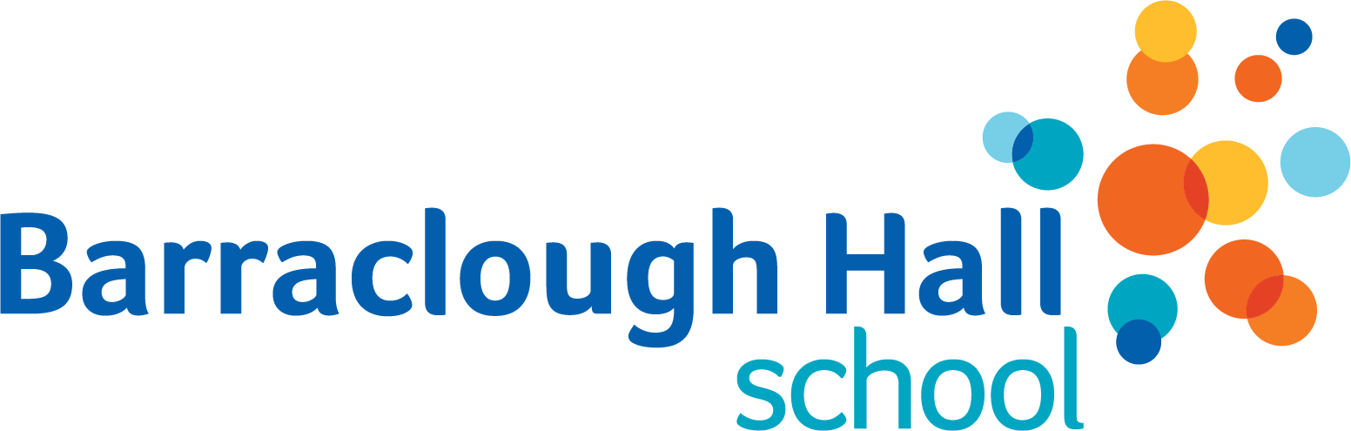
ANNUAL MEDICAL CONSENT FORM
for EDUCATIONAL VISITS
Please complete all shaded boxes on these forms
By signing the forms, the parent is agreeing to update the school if any of the details change over the year.
If there are no changes to make, these forms are completed once each academic year
Name of School | Barraclough Hall School | Academic Year
Name of Child |  |  | Year Group
Name of Parent(s)/Carer(s)

Please indicate Y or N to the following boxes:
I agree to my child taking part in Educational Visits
Yes / No
Is your child suffering from any conditions requiring medical treatment or medication?*
Are there any changes to your child’s medical health in the last year that staff should be aware of? If yes, give details below
*If your child is suffering from any conditions requiring medical treatment or medication, the school will also ask you to complete an Administration of Medication Consent Form.

Please outline the type of pain relief (e.g. paracetamol or ibuprofen) which may be given in the case of a short term condition (e.g. headache) in school or on a visit.
Please outline any special dietary requirements for your child
Yes / No
Does your child have any allergies, including to any medication?
If yes, please give details
When did your child last receive a tetanus injection

- I understand that the visits are insured in respect of legal liabilities (third party liability) but that my child has no personal accident cover unless I am specifically advised of this in writing by the organiser of the visit. I also understand that any extension of insurance cover is my responsibility unless advised differently by the organiser of the visit.
- For any visits, I will note where and when the children are to be returned and I understand that I am responsible for getting my child home safely from that place.
Signature of Parents/Carers with Legal Responsibility for the Child | Date

